sudo apt update

2 cd

3 service ssh restart

4 apt upgrade -y

5 sudo apt update

6 sudo apt install mysql-server

7 sudo systemctl start mysql.service

8 mysql_secure_installation

9 wget https://repo.zabbix.com/zabbix/6.0/ubuntu/pool/main/z/zabbix-release/zabbix-release_6.0-4+ubuntu20.04_all.deb

10 dpkg -i zabbix-release_6.0-4+ubuntu20.04_all.deb

11 apt install zabbix-server-mysql zabbix-frontend-php zabbix-apache-conf zabbix-sql-scripts zabbix-agent

12 mysql -uroot

13 zcat /usr/share/zabbix-sql-scripts/mysql/server.sql.gz | mysql --default-character-set=utf8mb4 -uzabbix -p zabbix

14 mysql -uroot

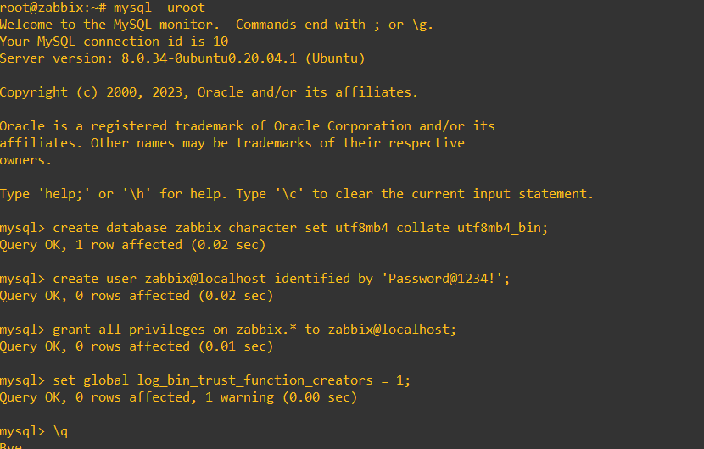

15 nano /etc/zabbix/zabbix_server.conf

16 systemctl restart zabbix-server zabbix-agent apache2

17 systemctl enable zabbix-server zabbix-agent apache2

18 ls

19 nmap -sA 192.168.50.0/24

20 cat /etc/reluname -m

21 uname -m

22 curl -so wazuh-agent.deb

23 curl -so wazuh-agent.deb https://packages.wazuh.com/4.x/apt/pool/main/w/wazuh-agent/wazuh-agent_4.4.5-1_amd64.deb && sudo WAZUH_MANAGER='192.168.101.251' WAZUH_AGENT_GROUP='linux' dpkg -i ./wazuh-agent.deb

24 sudo systemctl daemon-reload

25 sudo systemctl enable wazuh-agent

26 sudo systemctl start wazuh-agent

27 hostname SL-RE-ZABBIX01

28 nano /etc/hostname

29 reboot

30 history

31 cat /var/log/zabbix/zabbix_server.log

32 cat /var/log/zabbix/zabbix_agentd.log

33 nano /etc/zabbix/zabbix_agentd.

34 nano /etc/zabbix/zabbix_agentd.conf

35 nano /etc/zabbix/zabbix_server.conf

36 systemctl restart zabbix-server zabbix-agent apache2

37 ping 192.168.50.1

38 ping 192.168.50.50

39 ping 192.168.50.86

40 ping 192.168.50.84

41 ping 10.50.105.1000

42 ping 10.50.105.100

43 ping 10.50.105.101

44 ping 192.168.101.32

45 ping 192.168.101.33

46 ping 192.168.101.34

47 ping 192.168.101.251

48 history